**Image Registration methods in Python :**

→ Image registration is defined as a process that **overlays two or more images from various imaging equipment or sensors taken** at different times and angles, or from the same scene to geometrically align the images for analysis

→ **Image registration** is an **image processing** technique used to align multiple scenes into a single integrated **image**. It helps overcome issues such as **image** rotation, scale, and skew that are common when overlaying **images** .

**→Method 1 : Image Registration using chi2_shift method :**

**(1) Read our images :**

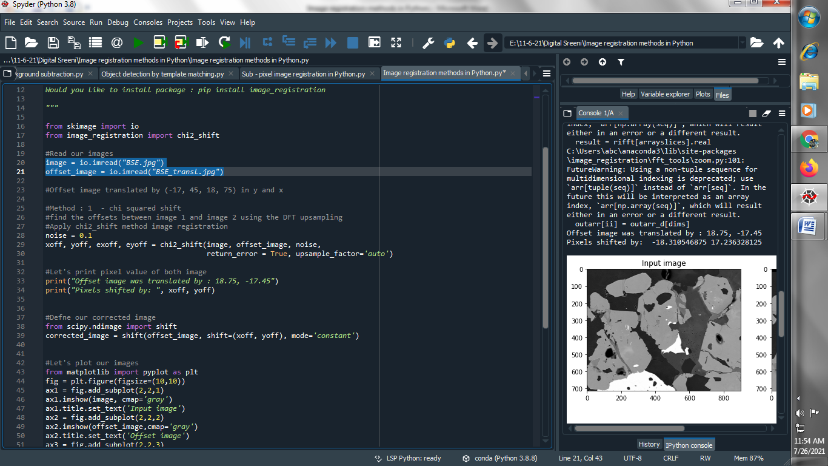

**(2) Apply chi2_shift method image registration :**

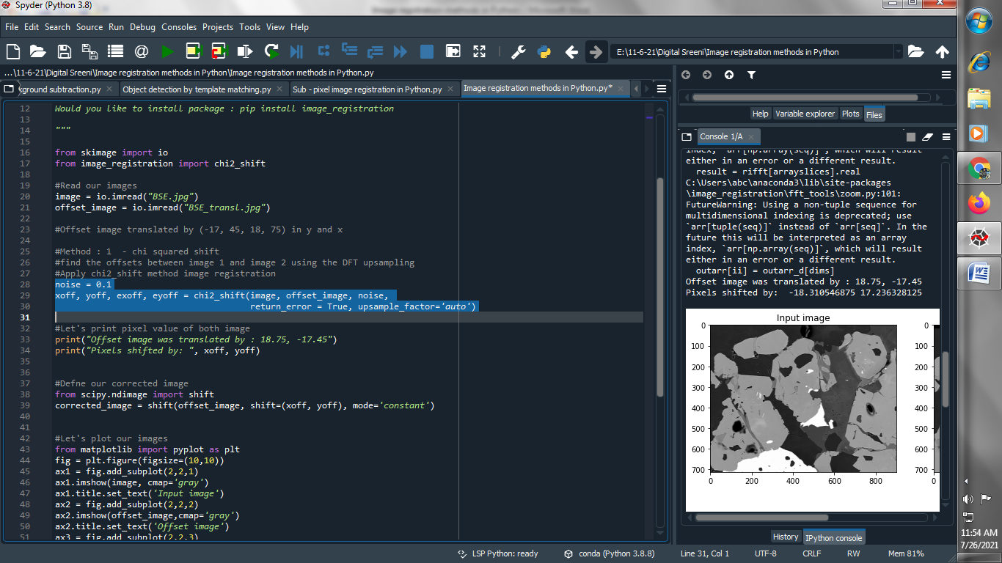

**(3) Let's print pixel value of both image :**

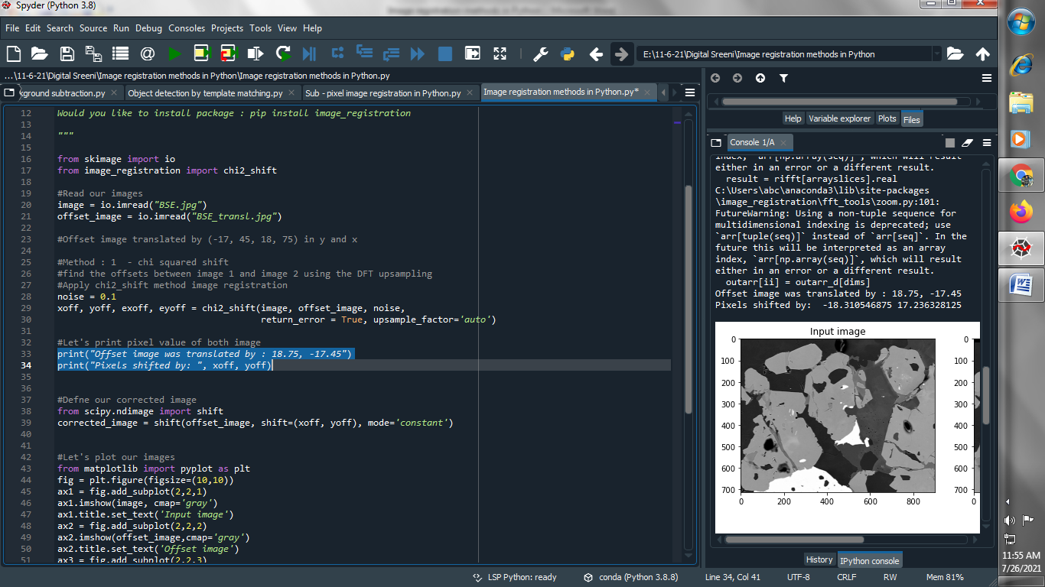

**Output :**

**Offset image was translated by : 18.75, -17.45**

**Pixels shifted by: -18.310546875 17.236328125**

**(4) Define our corrected image :**

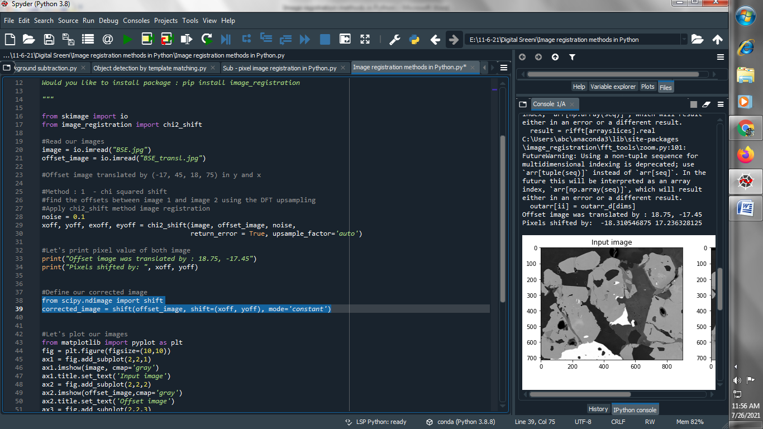

**(5) Let’s plot our image :**

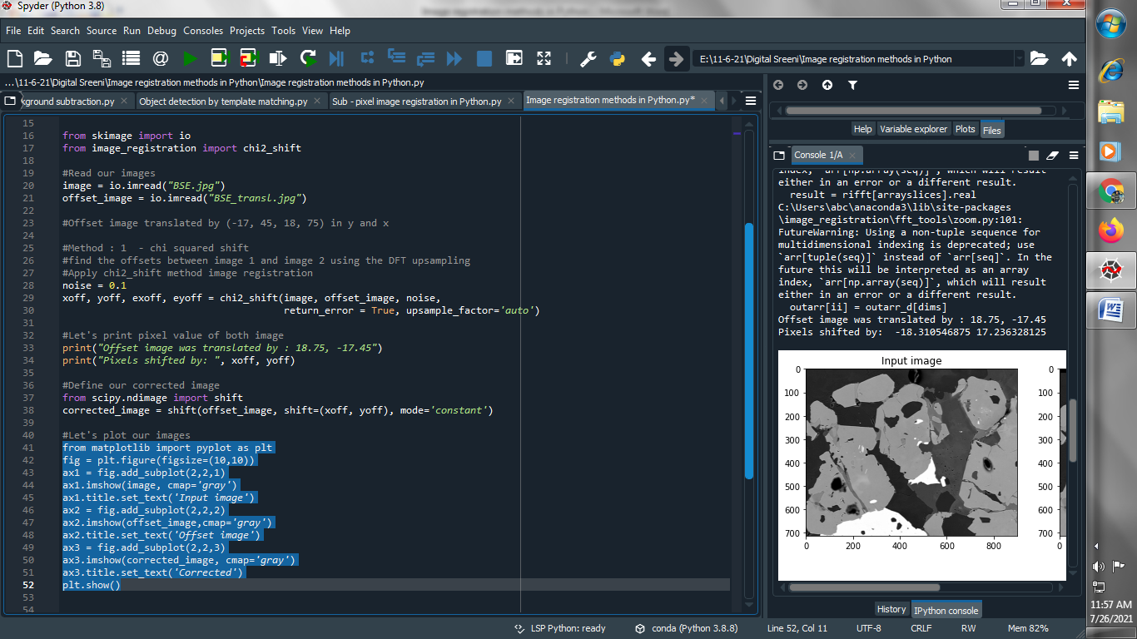

**Output :**

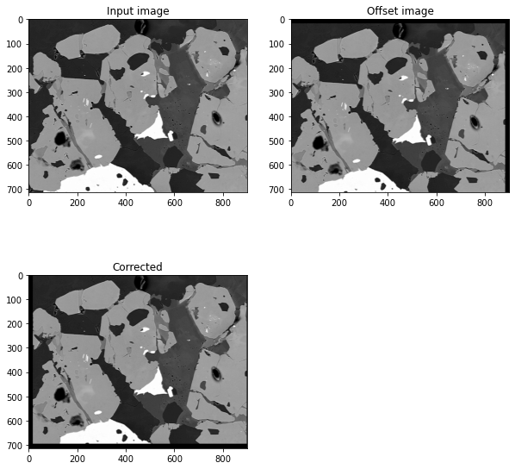

**###################################################################**

**→ Method 2 : Image Registration using cross correlation shift :**

**(1) Read our images :**

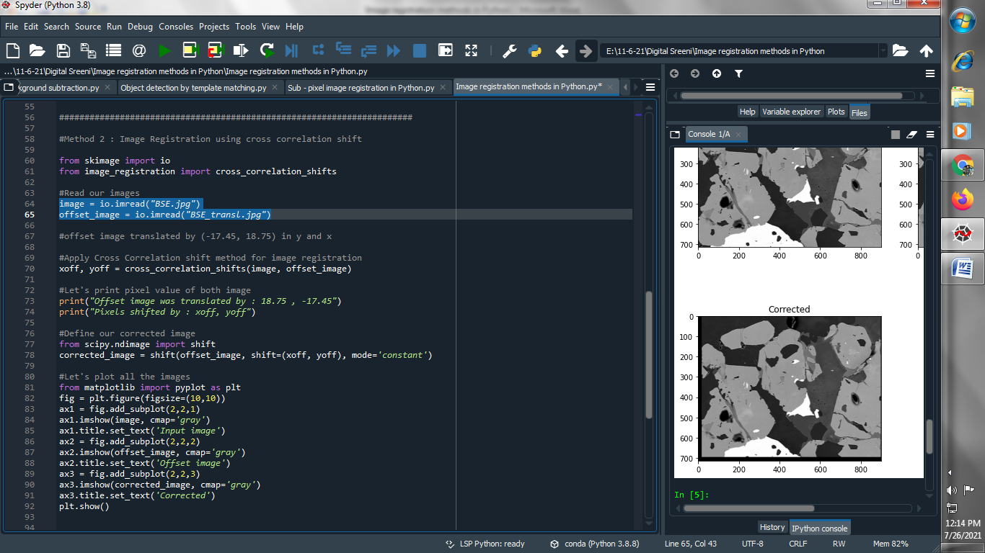

**(2) Apply Cross Correlation shift method for image registration :**

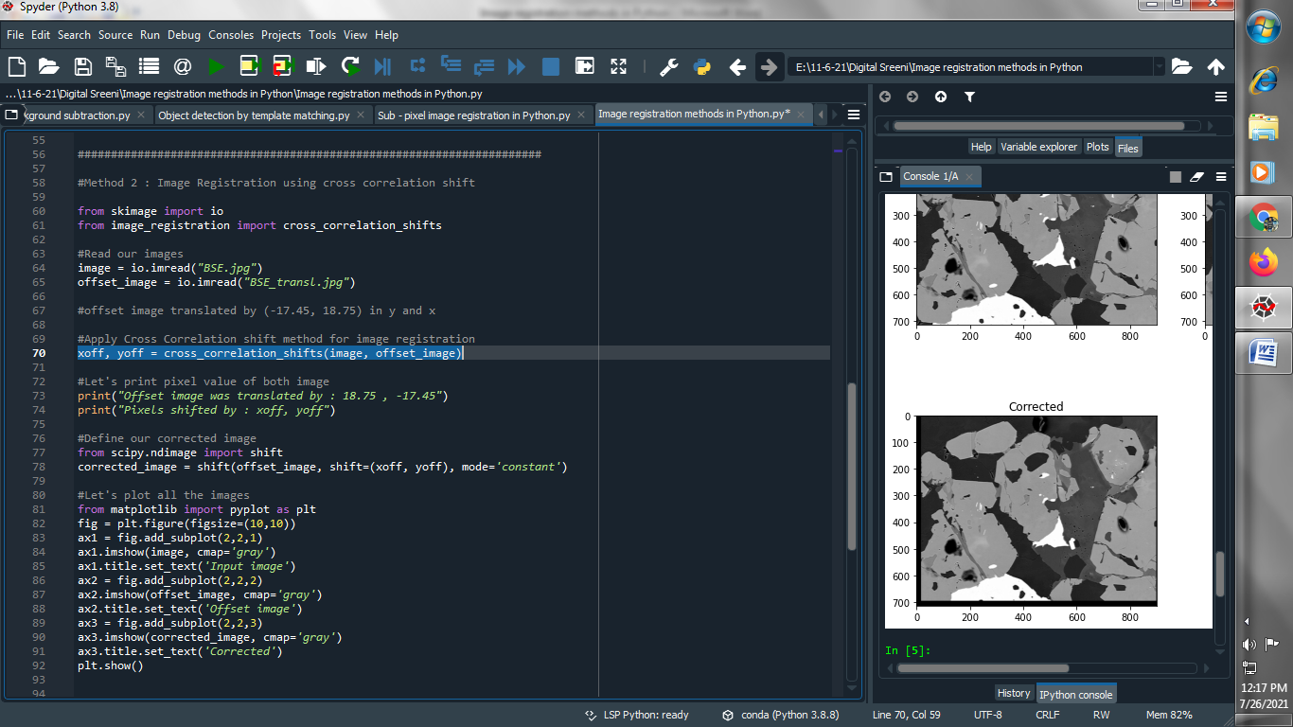

**(3) Let's print pixel value of both image :**

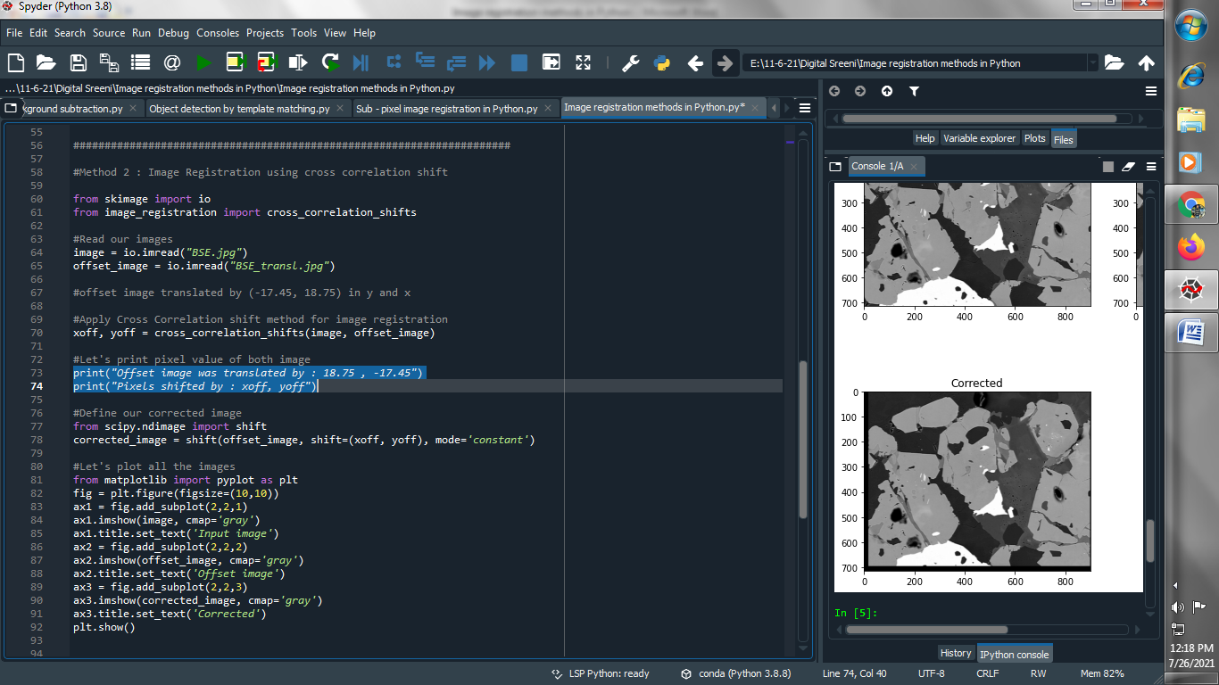

**Output :**

**Offset image was translated by : 18.75 , -17.45**

**Pixels shifted by : -18.383926143153136 17.258670200313837**

**(4) Define our corrected image :**

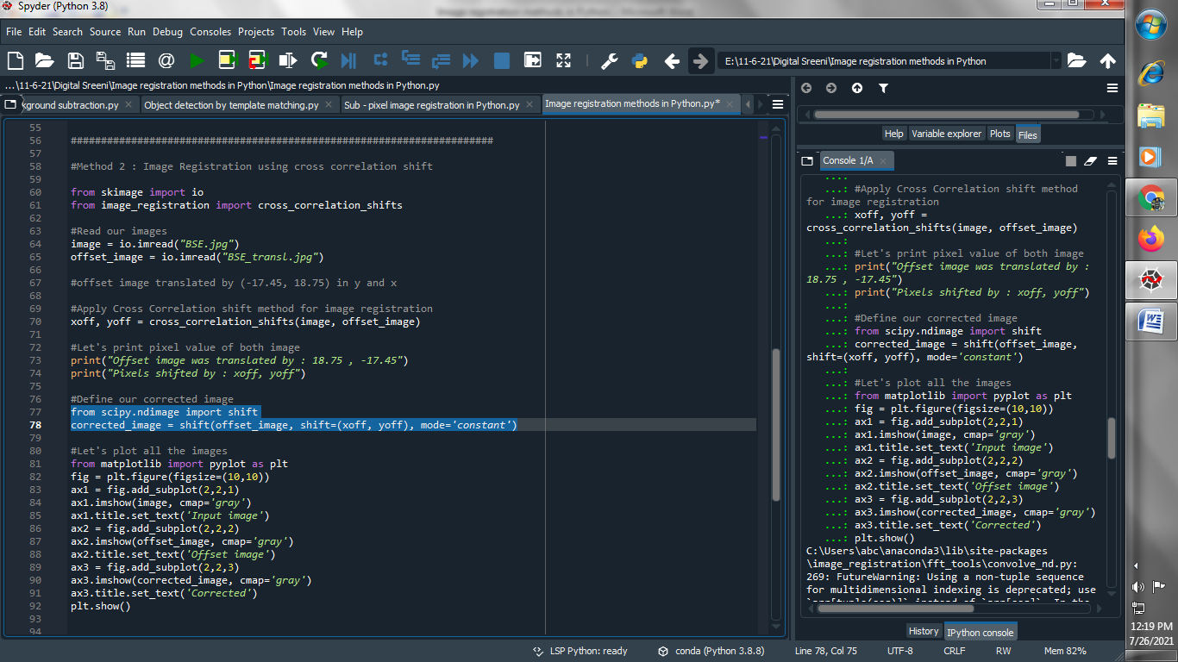

**(5) Let’s plot our all images :**

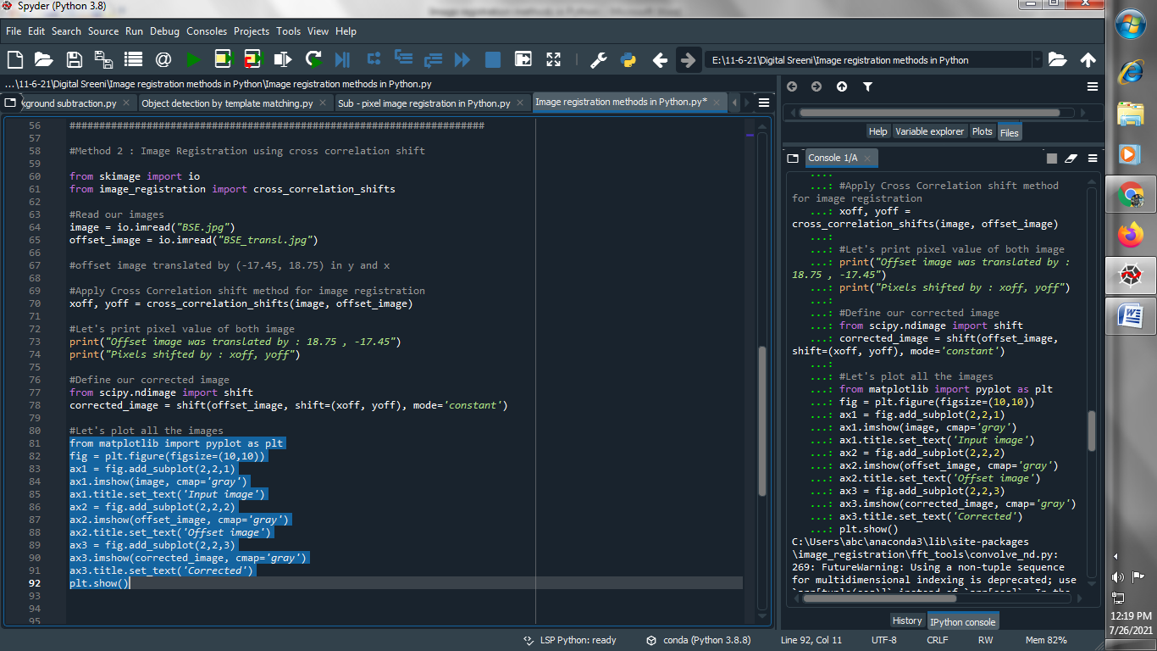

**Output :**

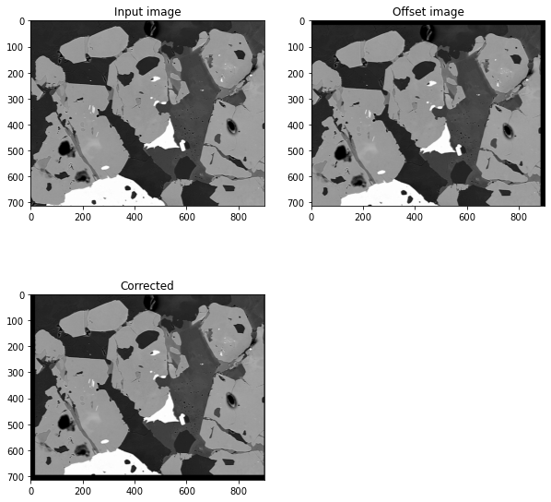

**###############################################################################**

**→ Method 3 : Image Registration using Optical flow based shift :**

**(1) Read our images :**

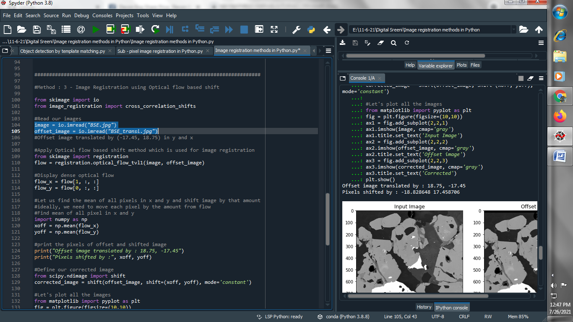

**(2) Apply Optical flow based shift method which is used for image registration :**

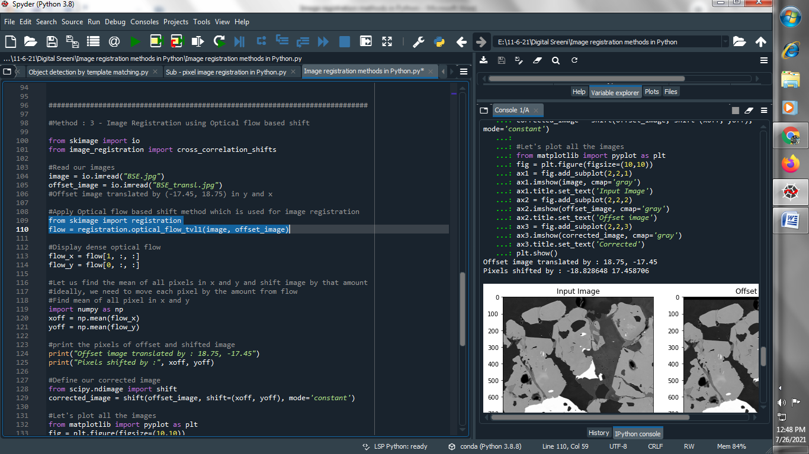

**(3) Display dense optical flow :**

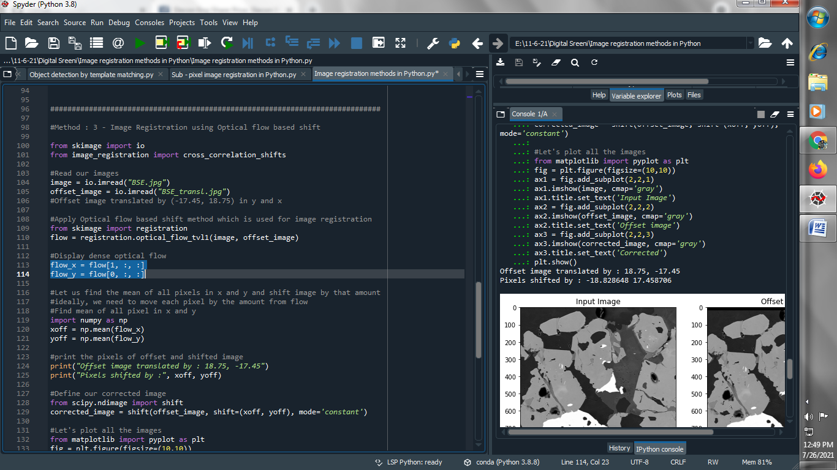

**(4) Find mean of all pixel in x and y :**

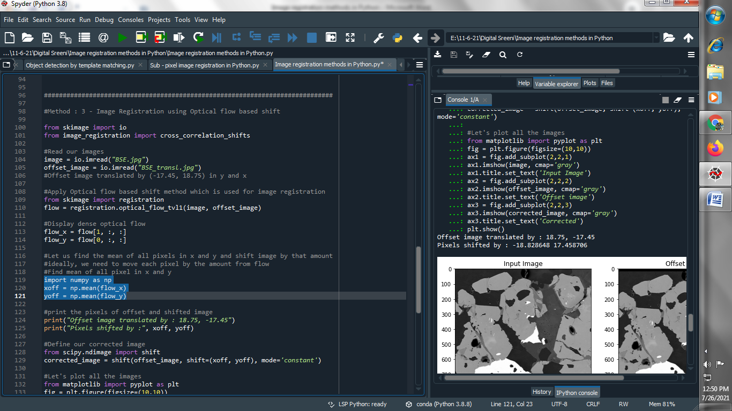

**(5) print the pixels of offset and shifted image :**

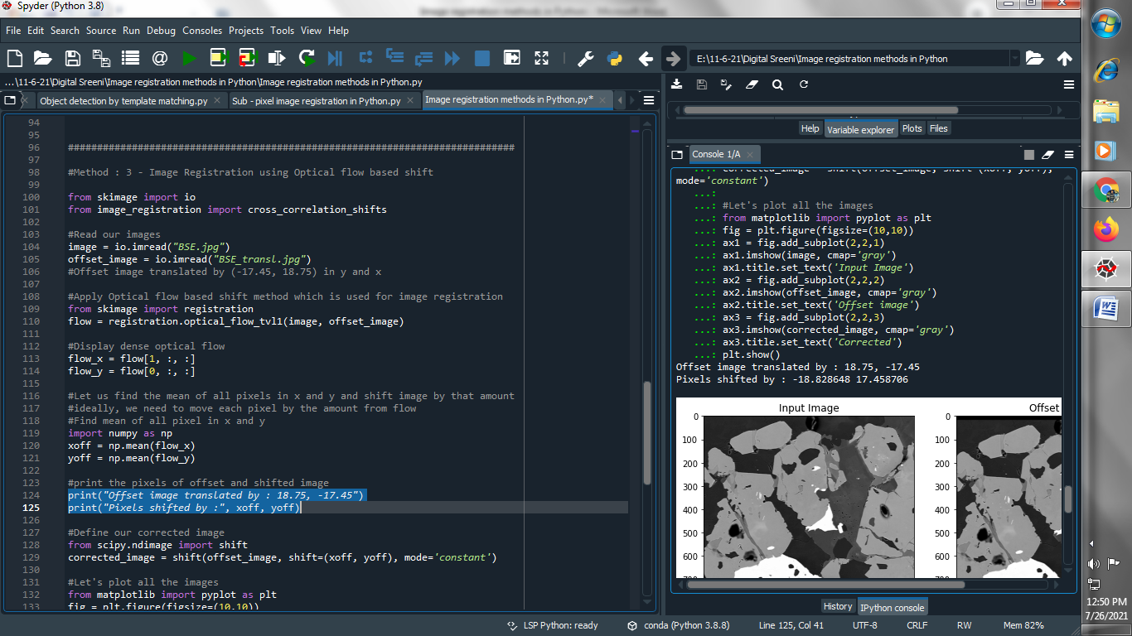

**(6) Define our corrected image :**

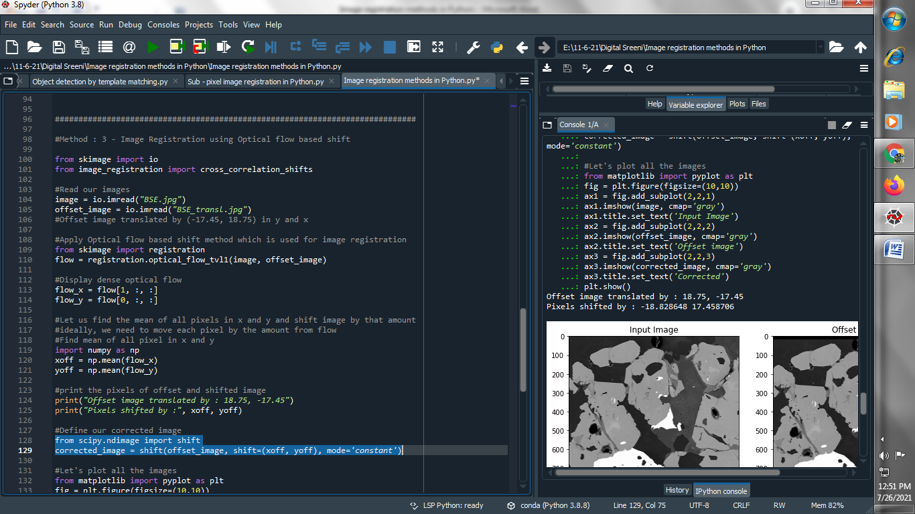

**(7) Let’s Plot our images :**

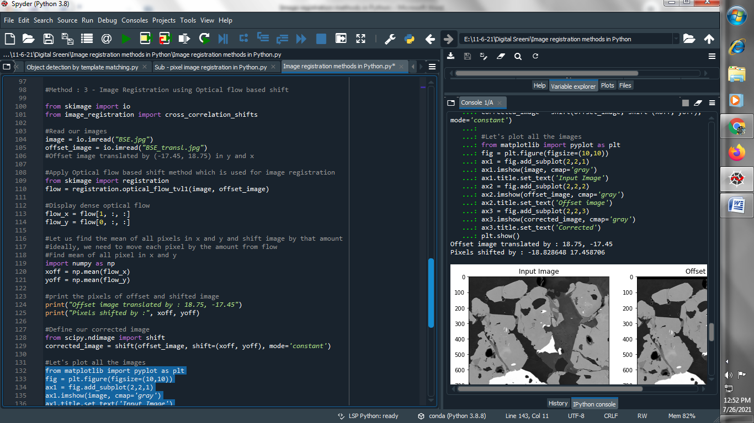

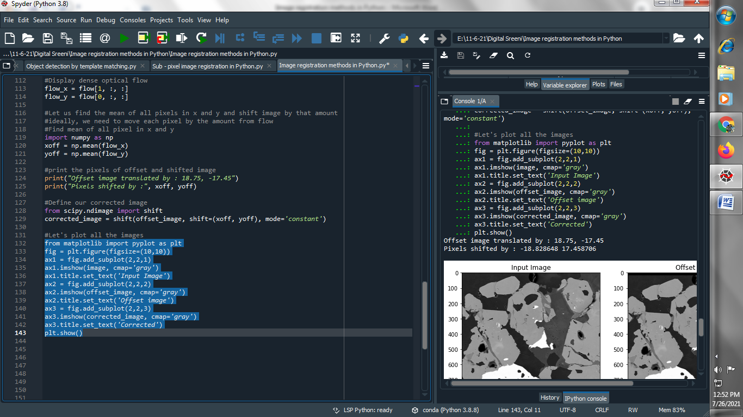

**Output :**

